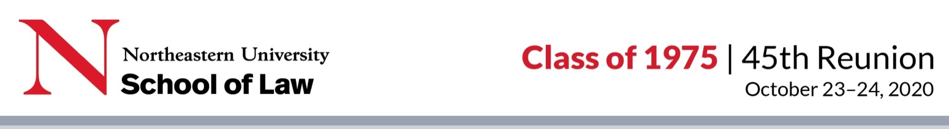

Be Part of the 1975 Class Book for Our 45th Reunion!
Please type your responses in the form below (the response areas expand as you type) and email your profile in Word format (not a pdf) and photos to Margie Palladino at margie@reunionsreinvented.com by September 16. If you have any questions about the form or photos, please contact Margie.

Your Contact Information (*required)

*Name:
*Home address(es):
*Phone number (cell or home):
*Email address:
Facebook Username:
Twitter Handle:
Instagram Handle:

Your Work (If you are retired, please note that you are retired)

Employer:
Location:
Description of Work:

Your Family

Please provide any information you want to share about your family (spouse/partner, children, grandchildren, etc.)

Your Life

Some topics you might consider: Work history, including military service; current work (paid or unpaid); interests; plans for the future; professional and personal achievements; how the law school may have shaped your life; what your classmates might be surprised to learn about you; anything else that tells your story.

Law School Retrospective

Please share your favorite memories of your NUSL days (recollections of an event, course, professor, classmate, etc.)

Career Retrospective

Any advice you might give to someone thinking of going to law school today?

Share Photos

Please email your headshot (or photo we can crop to use as one) and a few favorite photos to Margie Palladino at margie@reunionsreinvented.com. Attach one photo per email and keep the photo file as large as possible. Please describe your photos or provide a caption in your email. If you have any questions, please email Margie.

By submitting a profile or photos, you are consenting to have Reunions Reinvented and Northeastern University ("RR & Northeastern") edit, publish, or not publish them, and you release RR & Northeastern, their agents and employees from liability for any claims by you or any third party in connection with your participation.

