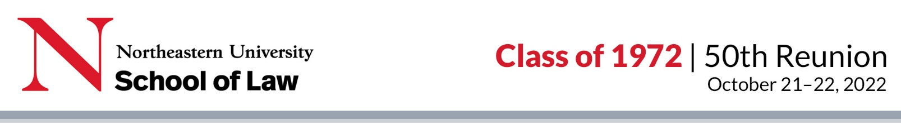
THE CLASS OF 1972 REUNION YEARBOOK

Dear Classmate,
We look forward to reuniting with you at our 50th reunion on October 21 and 22. In honor of our milestone reunion, we are creating a special memories reunion e-book that will include updates submitted by class members and our reminiscences of classmates who have passed on. Our e-book will be emailed before our Reunion to everyone in our class.
We invite you to tell us about the highlights of your journey after graduating from NUSL 50 years ago, your passions and interests, and your memories and reflections on our law school experience. Please include a current photo of yourself, and you are welcome to submit up to three favorite photos that show some aspects of your life, whether from law school, today, or in between.
How to submit an update: Please save this form to your computer, then type your responses in it and continue to save it as you edit or add to it. Each reply is limited to the amount of space in the box beneath the question. Once completed, email your saved form (do not create a pdf) and your photos to Margie Palladino at margie@reunionsreinvented.com.
How to submit remembrances of a deceased classmate: Please submit them in a Word document or by email (no pdfs please) to Margie Palladino at margie@reunionsreinvented.com. There is no word limit—even a few sentences are appreciated. Here is a list of our classmates who have passed on.
If you have any questions about the form, photos, or process, please contact Margie Palladino.
Deadline for submission: September 9, 2022

YOUR CONTACT INFORMATION (required)
Name
Home address
Phone number (cell or home)
Email address

YOUR WORK (optional)
If retired, please note that you are retired
Employer:
Location:
Brief Description of Work: (You can expand on your work in the Life section)

YOUR FAMILY AND THOSE NEAR AND DEAR TO YOU (optional)
Please provide any information you'd like to share about your family (your spouse/partner, children, grandchildren, etc.) and all whose lives are closely linked with yours (including pets).

Your Life over the past 50 years (optional)

Please provide an autobiographical entry along with a recent photo of yourself. It is up to you what you’d like to share about your life story. Some topics you might consider: Work history, including military service; current work (paid or unpaid); service to the community; passions and interests; plans for the future; professional and personal achievements; how the law school may have shaped your life; what your classmates might be surprised to learn about you; anything else that tells your story.

Your Life Story:

Continued...

Law School MEMORIES / Reflections (optional)
Please share your favorite memories of your law school days, recollections of any event, course, professor, or classmate that made a lasting impact on your life, or your reflections on how NUSL impacted your life.

Share Photos

Email a current headshot or photo we can crop to use as one – no hat or sunglasses please – and, if you would like to, up to three photos (ex.: family, travel, enjoying a pastime, etc.) to Margie Palladino at margie@reunionsreinvented.com. Attach one photo per email and keep the photo file large (at least 300kb for your headshot and at least 750kb for other photos). Describe your photo(s) or provide a caption in your email(s).

In addition, you are welcome to submit favorite photos from our law school days (graduation, sports, campus life, etc.). Please follow the above instructions to submit law school photos.

By submitting a profile or photos, you are consenting to have Reunions Reinvented and Northeastern University School of Law ("RR & NUSL") edit, publish, or not publish them, and you release RR & NUSL, their agents and employees from liability for any claims by you or any third party in connection with your participation.

